Name:_________________________________________ Date:____________
American Studies English
Into the Wild Creative Essay
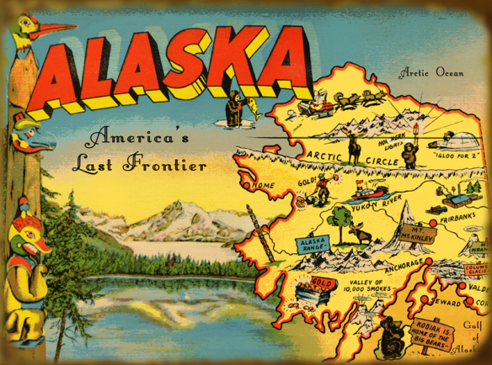

Into the Wild narrates the true story of Chris McCandless’s cross-country adventure and quest for self-discovery. After McCandless graduated from college, he traveled to various locations in the United States and ultimately journeyed into the Alaskan wilderness. One can certainly argue that Alaska was a location that truly inspired McCandless and sparked his love for adventure and nature. While McCandless desired to maintain a sense of independence, he did cultivate many meaningful relationships throughout his “odyssey”. To communicate with the people he met while he was on the road, he often sent postcards.
Assignment: You will follow in Chris McCandless’s footsteps by creating a postcard from a specific location that inspires you. Consider the mythological allure Alaska held for McCandless. What is a location that bears a similar significance to you?
Part I: Creating the Postcard
- The visual component of this assignment, the postcard, will be created on an 8”x 5” piece of poster board.

- On one side of the poster board you will create the postcard cover. Include images, a title, and be sure to make use of all white space.

- On the other side of the poster board, you will address the postcard to a potential person who you wish to send it to. Include a brief message that describes the specific location. Be sure to consider audience and purpose.

Part II: The Creative Essay
- Compose a three-paragraph essay that (1) describes your ideal place, (2) provides an anecdotal story that offers an example of the location’s allure, and (3) offers reflections as to why this location inspires you.

Into the Wild Creative Essay Rubric

Name:______________________________________________________

 | 4 | 3 | 2 | 1
Postcard: Neatness and Creativity | The postcard is extremely neat. It is well planned and reflects strong effort and creative thought. Makes use of all white space. | The postcard is neat. It is well planned and reflects effort and creative thought. Makes use of most white space. | The postcard is generally neat, but some aspects reflect poor planning and a lack of creativity. All white space is not used. | The postcard is messy and reflects poor planning and creativity.
Topic Development | The criteria for choosing the location is extremely clear, and relevant examples are weaved throughout the essay. The impact the location has had on the author’s life is explored through the essay in a manner that is both articulate and meaningful. | The criteria for choosing the location is clear, and most of the examples used in the essay are relevant. The impact the location has had on the author’s life is explored. | The criteria for choosing the location may vague, and some of the examples used in the essay may be contrived. The author of the essay does not explore the impact the location has had on the author’s life adequately. | The criteria for choosing the location is not clear, and examples are either not used or contrived. The author of the essay does not make an attempt to explore the location’s impact.
Organization and Structure | Essay is extremely well organized; has complete and clear topic sentences that effectively answer the prompt; details follow in logical order. | Essay is well-organized; mostly complete and clear topic sentences that effectively answer the prompt; most details follow in logical order. | Essay may have 1-2 errors in organization; details follow in a somewhat logical order but there may be errors in topic sentence structure. | Essay has inadequate topic sentences that do not effectively answer the prompt; details that follow are not in logical order.
Style: Word Choice and Sentence Structure | Essay includes varied word choice and sophisticated and appropriately used vocabulary words; sentence structure is varied and contributes to the overall fluidity of the essay. | Word choice in the essay is generally varied, sophisticated vocabulary is incorporated throughout most of the paper although 1-2 words may need to be revised; sentence structure is generally varied, but 1-2 passages of the essay may be somewhat choppy. | Some words are repeated continuously throughout the essay; there is a need for more sophisticated vocabulary; sentence structure lacks variation in 3-4 passages and creates a sense of choppiness to the essay. | Essay lacks the incorporation of sophisticated vocabulary and varied sentence structure.
Grammar & Spelling (Conventions) | Writer makes no errors in grammar or spelling that distract the reader from the content of the essay. | Writer makes 1-2 errors in grammar or spelling that distract the reader from the content of the essay | Writer makes 3-4 errors in grammar or spelling that distract the reader from the content of the essay. | Writer makes more than 4 errors in grammar or spelling that distract the reader from the content of the essay.
MLA Format/Elements of the Writing Process | Assignment is in MLA format and all elements of the writing process are included. | 1-2 mistakes in MLA format; some elements of the writing process may be missing. | 3-4 mistakes in MLA format; some elements of the writing process may be missing. | Numerous mistakes in MLA format. Many elements of the writing process are not present.

SUMMATIVE FEEDBACK
STRENGTHS | AREAS TO IMPROVE
_____ Your postcard is visually appealing and demonstrates strong consideration of audience and purpose.  ______Excellent topic selection.  _____ The significance of your location is strengthened with strong examples.  _____ Sophisticated word choice and strong use of sensory details.  _____ Meaningful insights into the value of your chosen location.  _____ Your essay has clear topic sentences and is well organized.  _____ Precise attention to MLA and the writing process. | _____ Develop the visual appeal of your postcard.  _____ Pay attention to organization and topic sentence structure.  _____ Develop more dynamic word choice and incorporate sensory details.  _____ Enrich your essay by incorporating stronger examples.  _____ Be consistent with MLA and formatting rules.  _____ Proofread to be aware of issues with spelling, grammar and mechanics.

