Notes: Native American Literature

Why do we study Native American literature?

- To educate ourselves on the values and customs of the Native Americans.

- To empower ourselves to understand how Native American culture and literature has shaped the story of American literature.

Overview

-When the Europeans arrived in America (the late 1400s were a time of great European exploration, Columbus arrived in 1492), more than 300 different Native American cultures existed.

- Native American tribes are categorized into 8 different geographical groups: Eastern Woodland, Great Plains, Plateau, Northwest Coast, California, Great Basin, Southwest, and Southeast.

*Interesting fact: Cherokees, living primarily in Oklahoma, are currently the largest tribe.

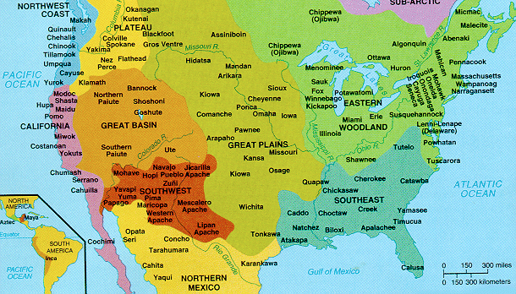

-The tribes focused on fishing, hunting, gathering, and farming, depending on the geographical location of the tribe.

- Each tribe had a different culture, but all Native American tribes shared oral tradition.

-Oral tradition uses storytelling to pass histories, legends, and myths down from generation to generation.

- Oral tradition functions to teach the history and values of a culture and to explain natural phenomena.

- Unfortunately, many Native Americans died from diseases brought by European settlers. In some groups, as much as 90% of the population passed away.

Native American Beliefs

- All Native American cultures in North America adopted coherent religious systems.

- Most groups believe in a Creator, other supernatural entities, and a figure of evil.

- Many groups also believe in the immortality of the human soul (reincarnation or the afterlife).

- The belief of a union between material and spiritual worlds is also common. In other words, all natural objects in the universe, such as plants, animals, trees, rocks, have spirits. This is also known as animism.

Shaman- a religious leader who communicates with the spiritual world.

Medicine man- a priestly healer and spiritual leader.

Totemism- a belief practiced by Northwest tribes in which a natural object or animate being (ex. a bird) is the emblem of a family clan or tribe. This object/being bears spiritual significance and is symbolic of a guardian spirit. Totem poles are a way to display these significant emblems.

Creation Stories

- For the Native Americans, creation stories are ways to explain how the universe came into being.

- Many creation stories are similar from tribe to tribe.

- The origins of tribal customs and values are evident in creation stories.

Common Motifs in Native American Literature

- The creator/a medium for creation.

- The Trickster –Trickster tales are a type of creation story. Tricksters are more than deceivers. They cross boundaries and break rules to teach just how important rules are (remember the functions of oral tradition- to teach and explain).

- Traditional elements: buffalo, coyotes, and spiders, corn, clay, obsidian, holy mountains, the vast sea, weather and storms.

- Relationships between humans and animals.

-Respect and reverence for Mother Earth and nature.

-Cyclical patterns: renewal and continuance.

