Name:___________________________________ Date:_______

American Studies English (Standard)
Into the Wild: Thesis Essay

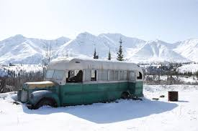

John Krakauer’s non-fiction text Into the Wild presents Chris McCandless as a man who refutes the traditional notion of the “American Dream”. While the American Dream is frequently associated with financial independence and prosperity, McCandless rejects such ideals.

Your assignment is to compose a four-paragraph, thesis-driven essay that responds to the following prompt:

What do McCandless’s values, such as the rejection of material items and traditional authority, reveal about his definition of the American Dream?

Main idea: In John Krakauer’s nonfiction text Into the Wild, Chris McCandless’s rejection of ________________________________ (DI#1) and ______________________________ (DI #2) reveal that he pursues an unconventional notion of the American Dream.

Essay Structure:

Introduction: Background Information, Main Idea, Developmental Ideas

Developmental Paragraph #1: This paragraph will be composed of a topic sentence, two DQ sandwiches, and a concluding sentence.

Developmental Paragraph #2: This paragraph will be composed of a topic sentence, two DQ sandwiches, and a concluding sentence.

Concluding Paragraph: Creatively restate your Main Idea and include a Reach for Significance.

Questions to Guide Your Analysis:
- What value does the DQ reveal?
- What elements of the DQ suggest this value?
- How does this value contribute to McCandless’s unconventional idea of the American Dream?

Main idea: In John Krakauer’s nonfiction text Into the Wild, Chris McCandless’s rejection of __________________________ (DI#1) and _______________________ (DI #2) reveal that he pursues an unconventional notion of the American Dream.

Idea Tree

