Humanities Name: __________________
Mr. Haflin
Essay #8

A Christmas Carol Theme Analysis
Charles Dickens’s novella, A Christmas Carol, explores themes as relevant to our time period as they were to London in the 1840s. An instant bestseller, the novella has captivated audiences since its publication. A Christmas Carol has been adapted into 21 different movies as well as a variety of theatrical productions. We will be viewing the 2009 Disney adaptation, starring Jim Carrey as Scrooge.

In a well-constructed thesis essay (4 paragraphs), discuss how the film develops TWO of the following themes:
- Poverty/unjust treatment of the poor
- Greediness
- Forgiveness
- Redemption
- Tradition
- Family
- Threat of Time

Each essay paragraph should include the following:

- Introduction: Background information on A Christmas Carol (both the novella and movie adaptation), a CI, MI (which introduces your DIs), and hint at your RFS.
- Body Paragraph: Discussion of theme #1 (DI 1). How does the movie develop the theme? What instances can the audience see thematic development before our eyes? Use at least three (3) examples to support your argument.
- Body Paragraph: Discussion of theme #2 (DI 2). Same as Body Paragraph #1
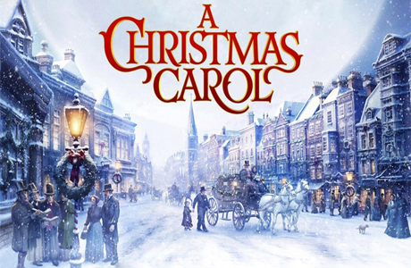
- Conclusion: Restate CI and MI (which includes your DIs). Include an RFS which reflects on the importance of viewing A Christmas Carol, even in modern times.

