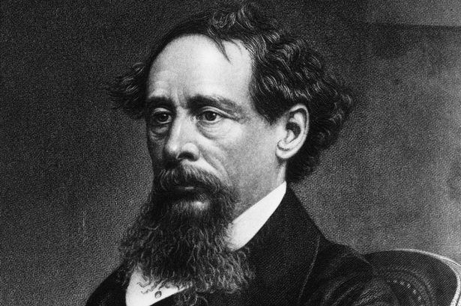 Agenda #24
June 5th to
Humanities (2) Mr. Haflin
 | Block A | Block F
Tuesday  June 5  Day 1 | Classwork  Review Chapters 2-3  Assign Essay #15 (final Essay)  Survivor Game  Homework  - Please finish reading Chapters 4-6 for Friday and answer the SG questions for HW #14 | Classwork  Assign Essay #15 (final Essay)  Independent Reading  Homework  - Reading Check Friday on Chapters 4-6!  - HW #14 due Friday!  Essay #15 Brainstorm due Friday!
Wednesday  June 6  Day 2  Bio MCAS—who’s missing? | Classwork  Independent Reading/ NO CLASS (Bio MCAS)  Homework  - Reading Check Friday on Chapters 4-6!  - HW #14 due Friday!  - Essay #15 Brainstorm due Friday! | No Class Today Same Homework as Day 1
Thursday  June 7  Day 3  Bio MCAS—who’s missing? | Classwork  BIO MCAS No Class  Homework  - Reading Check Friday on Chapters 4-6!  - HW #14 due Friday!  - Essay #15 Brainstorm due Friday! | Classwork  Survivor Game  Homework  - Reading Check Friday on Chapters 4-6!  - HW #14 due Thursday!  - Essay #15 Brainstorm due Friday!
Friday  June 8  Day 4 | Classwork  Reading Check on 4-6  Collect HW #14  Brainstorm 1-3 Due (check)  Homework  - Please read Chapters 7-10 for Tuesday (HW #15 due Wednesday)  - Please finish Brainstorm #4-5 for Monday | Classwork  Reading Check on 4-6  Collect HW #14  Brainstorm 1-3 Due (check)  Homework  - Please read Chapters 7-10 for Tuesday (HW #15 due Wednesday)  - Please finish Brainstorm #4-5 for Monday
Monday  June 11  Day 5 | Classwork  Brainstorm due (Check)  Working on Scene (Review Requirements)  Independent Reading  Homework  - Chapters 7-10 due for tomorrow (HW #15 due Thursday) | Classwork  Brainstorm due (Check)  Working on Scene (Review Requirements)  Independent Reading  Homework  - Chapters 7-10 due for tomorrow (HW #15 due Wednesday)
Tuesday  June 12  Day 6 | Classwork:  Reading Check Chapters 7-10  Working on Scene  Working on Analytical Paragraphs Review Requirements  Independent Reading  Homework  - Please finish reading Lord of the Flies and finish HW #15 for Thursday | Classwork:  Reading Check Chapters 7-10  Working on Scene  Working on Analytical Paragraphs Review Requirements  Independent Reading  Homework  - Please finish reading Lord of the Flies and finish HW #15 for tomorrow
Wednesday  June 13  Day 7 | No Class Today Same HW as Day 6 | Classwork  HW #15 Due Review End of the book  Independent Essay Work  Assign Final Exam Packet  Homework  - Essay #15 due tomorrow
Thursday  June 14  Day 1 | Classwork  HW #15 Due Review End of the book  Independent Essay Work  Assign Final Exam Packet  Homework  - Essay #15 due tomorrow | Classwork  In-Class Awards and Final Reflections  Course Evaluation  Exam Packet Work  Homework  - Study for final exams!  - Be awesome
Friday  June 15  Day 2 | Classwork  In-Class Awards and Final Reflections  Course Evaluation  Exam Packet Work  Homework  - Study for final exams!  - Be awesome | No Class Today Same HW as Day 6
Exams: | 8 AM Monday, June 18th  Room:  Proctor:  Bring your annotated packet!! | 8 AM Monday, June 18th  Room:  Proctor:  Bring your annotated packet!!
A look ahead:

