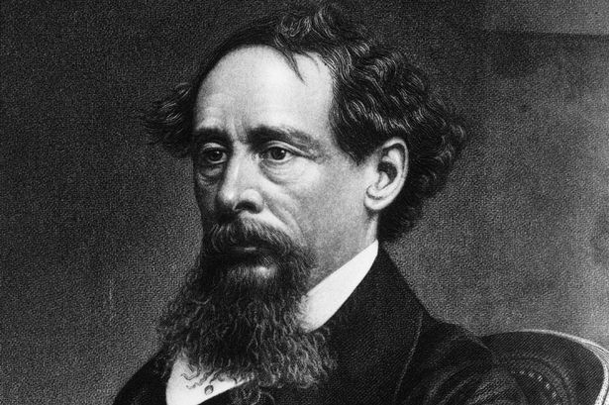 Agenda #23
May 24th to June 4th
Humanities (2) Mr. Haflin
 | Block A | Block F
Thursday  May 24  Day 1 | Classwork  In-Class work on Chart/Reading  Reading Chapter 10 together  Homework  - Please finish the novel for tomorrow (HW #13) | Classwork  Review all of HW #13  In-Class work on Chart/Reading  Homework  - No homework weekend!
Friday  May 25  Day 2  No Homework Weekend! | Classwork  Review all of HW #13  In-Class work on Chart/Reading  Homework  - No homework weekend! | No Class Today Same Homework as Day 1
Tuesday  May 29  Day 3 | Classwork  Reviewing the end of the novel: HW #13  End-of-Novel Discussion  Jeopardy Review Board: A Bonus Point?  Final Notes on Essay  Homework  - In-Class Essay tomorrow!  - Test on Thursday! (No Essay) | Classwork  Reviewing the end of the novel: HW #13  End-of-Novel Discussion  Jeopardy Review Board: A Bonus Point?  Final Notes on Essay  Homework  - In-Class Essay tomorrow!  - Test on Thursday! (No Essay)
Wednesday  May 30  Day 4 | Classwork  In-Class (Essay #14)  Homework  - Test tomorrow (no essay) | Classwork  In-Class (Essay #14)  Homework  - Test tomorrow (no essay)
Thursday  May 31  Day 5 | Classwork  Test on A Tale of Two Cities  Turn Back Essays/Work  Collect Books  Distribute Lord of the Flies  Homework  - Please complete the introduction to LotF sheet (with online Prezi) for tomorrow  - Please read Chapter One of Lord of the Flies for tomorrow and start HW #14 | Classwork  Test on A Tale of Two Cities  Turn Back Essays/Work  Collect Books  Distribute Lord of the Flies  Homework  - Please complete the introduction to LotF sheet (with online Prezi) for tomorrow  - Please read Chapter One of Lord of the Flies and start HW #14 for tomorrow
Friday  June 1  Day 6 | Classwork  Reading Check: Chapter 1  Reviewing Philosophy  Close Reading First Paragraph (Symbolism)  Start Reading Chapter 2  Homework  - Please read Chapters 2-3 for Tuesday  - Continue working on HW #14 | Classwork  Reading Check: Chapter 1  Reviewing Philosophy  Close Reading First Paragraph (Symbolism)  Start Reading Chapter 2  Homework  - Please read Chapters 2-3 for Monday  - Continue working on HW #14
Monday  June 4  Day 7 | No Class Today Same HW as Day 6 | Classwork  Review Chapters 2-3  Survivor Game  Homework  - Please finish reading Chapters 4-6 for Thursday and answer the SG questions for HW #14
A look ahead:
Reading Lord of the Flies
HW #14 due Thursday
Essay #15 Creative Piece

