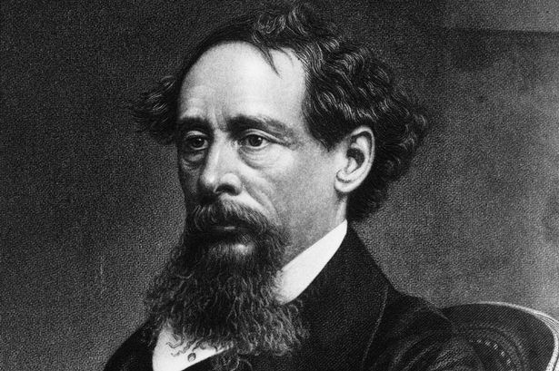 Agenda #22
May 15th to May 23rd
Humanities (2) Mr. Haflin
 | Block A | Block F
Tuesday  May 15  Day 1 | Classwork  DP #2 due: review and questions  Start composing conclusion  Individual Work on conclusion and Reading  Homework  - Please finish Reading Book 2, Chapters 20-24 and complete SG questions for tomorrow (HW #11)  - Please compose your conclusion for tomorrow. PRINT | Classwork  HW #11 due: Review  Peer Edit DP #2 and Conclusion  Motif and Symbols Chart, Revisited  Homework  - Please finish editing Essay #13 and submit to turnitin.com and GC by Thursday, 5/17.  - Quiz on Book 2 Thursday, 5/17
Wednesday  May 16  Day 2 | Classwork  HW #11 due: Review  Peer Edit DP #2 and Conclusion  Motif and Symbols Chart, Revisited  Homework  - Please finish editing Essay #13 and submit to turnitin.com and GC by tomorrow  - Quiz on Book 2 tomorrow | No Class Today Same Homework as Day 1
Thursday  May 17  Day 3 | Classwork  Essay #13 due  - Collect Passports, Prewriting  Book 2 Quiz  Give HW #12 (reading)  Homework  - Please read Book 3, Chapters 1-2 for tomorrow  - We will read Chapter 3 in class tomorrow  - Start working on HW #12 for Tuesday, 5/22 | Classwork  Essay #13 due  - Collect Passports, Prewriting  Book 2 Quiz  Give HW #12 (reading)  Homework  - Please read Book 3, Chapters 1-2 for tomorrow  - We will read Chapter 3 in class tomorrow  - Start working on HW #12 for Tuesday, 5/22
Friday  May 18  Day 4 | Classwork  Read Chapter 3 together  Assign In-Class (Essay #14) Chart Prep  Homework  - Please finish reading Chapters 3-6  - Continue working on HW #12 for Tuesday, 5/22 | Classwork  Read Chapter 3 together  Assign In-Class (Essay #14) Chart Prep  Homework  - Please finish reading Chapters 3-6  - Continue working on HW #12 for Tuesday, 5/22
Monday  May 21  Day 5 | Classwork  Returning Essays/Quizzes  Review Reading (one part of question only)  Reading Ch. 7/Working on Chart  Homework  - Please finish Chapters 7-8 and HW #12 for tomorrow  - Continue working on charts! | Classwork  Returning Essays/Quizzes  Review Reading (one part of question only)  Reading Ch. 7/Working on Chart  Homework  - Please finish Chapters 7-8 and HW #12 for tomorrow  - Continue working on charts!
Tuesday  May 22  Day 6 | Classwork  HW #12 Due Review  In-Class work on Chart/Reading  Homework  - Please read Chapter 9 for Thursday  - We will read all of Chapter 10 Thursday in class  - Please finish the novel for Friday (HW #13) | Classwork  HW #12 Due Review  In-Class work on Chart/Reading  Homework  - Please read Chapter 9 for tomorrow  - We will read all of Chapter 10 tomorrow in class  - Please finish the novel for Thursday (HW #13)
Wednesday  May 23  Day 7 | No Class Today Same HW as Day 6 | Classwork  In-Class work on Chart/Reading  Reading Chapter 10 together  Homework  - Please finish the novel for tomorrow (HW #13)
A look ahead:
No homework weekend for Memorial Day!
In-Class Essay #14 Wednesday, 5/30
Unit Test Thursday, 5/31

