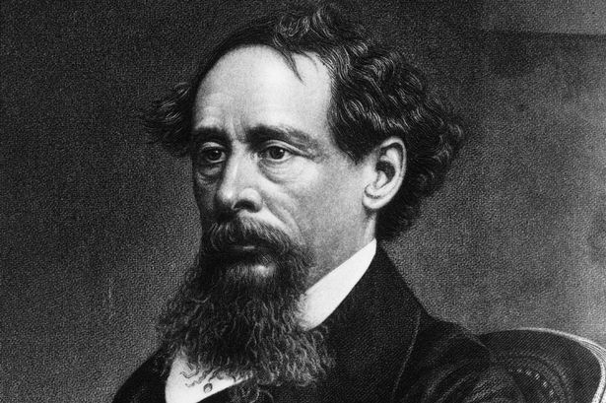 Agenda #21
May 4th to May 14th
Humanities (2) Mr. Haflin
 | Block A | Block F
Friday  May 4  Day 1  Star Wars Day  I Remember Mama—7:30 | Classwork  Review Book 1 Quiz Reflecting  Review HW #5  HW #6 due: Review  Pick Up “America the Beautiful” Essay #13  Reading Chapters 7-8  Homework  - Start coming up with ideas for your passport (working in-class Monday)  - Finish reading Chapters 7-8 for Monday (reading check) | Classwork  HW #6 due Review  Class Read Chapters 7-8  Reading Check: Book 2, Chapters 1-8 Review  Assign “America the Beautiful” Essay #13  Working on Passport  Homework  - Please finish the passport for Wednesday  - Please finish reading Chapters 9-10 for Tuesday
Monday  May 7  Day 2 | Classwork  Reading Check on Chapters 7-8/Review  Working on Passport portion  Start Reading Chapters 9-10  Homework  - Please finish the Passport for Wednesday  - Please finish reading Chapters 9-10 (HW #7) for tomorrow | No Class Today Same Homework as Day 1
Tuesday  May 8  Day 3 | Classwork  HW #7 due: Review  Motifs and Themes Review Sheet  Start reading Chapters 11-12  Homework  - Please finish reading Chapters 11-14 and answer the SG questions (HW #8) due tomorrow  - Please finish the Passport for tomorrow | Classwork  HW #7 due: Review  Motifs and Themes Review Sheet  Start reading Chapters 11-12  Homework  - Please finish reading Chapters 11-14 and answer the SG questions (HW #8) due tomorrow  - Please finish the Passport for tomorrow
Wednesday  May 9  Day 4 | Classwork  Passport due: Collect  HW #8 due: Review  Review format and requirements for the letter of sponsorship/condemnation  Individual Work on Essay #13: Brainstorming  Reading Chapters 15-16  Homework  - Please finish reading Chapters 15-16 (HW #9) and answer the SG questions due tomorrow  - Please write either your introduction to the Letter or DP #1 for tomorrow. NO PRINT. | Classwork  Passport due: Collect  HW #8 due: Review  Review format and requirements for the letter of sponsorship/condemnation  Individual Work on Essay #13: Brainstorming  Reading Chapters 15-16  Homework  - Please finish reading Chapters 15-16 (HW #9) and answer the SG questions due tomorrow  - Please write either your introduction to the Letter or DP #1 for tomorrow. NO PRINT.
Thursday  May 10  Day 5 | Classwork  HW #9 due: Review  Reviewing Format/Requirements for letter of sponsorship/condemnation  Individual Work on Essay #13  Reading Chapters 17-19  Homework  - Please finish reading Chapters 17-19 and answer the SG questions (HW #10) due tomorrow  - DP #1 or introduction due tomorrow (whichever you didn’t complete already). PRINT. | Classwork  HW #9 due: Review  Reviewing Format/Requirements for letter of sponsorship/condemnation  Individual Work on Essay #13  Reading Chapters 17-19  Homework  - Please finish reading Chapters 17-19 and answer the SG questions (HW #10) due tomorrow  - DP #1 or introduction due tomorrow (whichever you didn’t complete already). PRINT.
Friday  May 11  Day 6  Midterm Grades! | Classwork  HW #10 due: Review  Discussion: What do the characters know about one another?  Peer Editing Introduction and DP #1: Focusing on Tone and Requirements  Reading Chapter 20 in Class  Homework  - Please edit Intro and DP #1, compose DP #2 for Tuesday (no print)  - Please finish Reading Book 2, Chapters 20-24 and complete SG questions for Wednesday (HW #11) | Classwork  HW #10 due: Review  Discussion: What do the characters know about one another?  Peer Editing Introduction and DP #1: Focusing on Tone and Requirements  Reading Chapter 20 in Class  Homework  - Please edit Intro and DP #1, compose DP #2 for Monday (no print)  - Please finish Reading Book 2, Chapters 20-24 and complete SG questions for Tuesday (HW #11)
Monday  May 14  Day 7 | No Class Today Same HW as Day 6 | Classwork  DP #2 due: review and questions  Start composing conclusion  Individual Work on conclusion and Reading  Homework  - Please finish Reading Book 2, Chapters 20-24 and complete SG questions for tomorrow (HW #11)  - Please compose your conclusion for tomorrow. PRINT
A look ahead:
Finishing Essay #13
Book 2 Quiz
Finish Reading AToTC
In-Class Essay #14
Lord of the Flies

