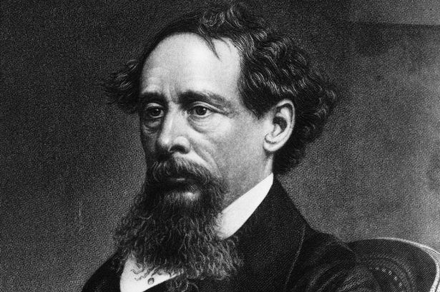 Agenda #20
April 25th – May 3rd
Humanities (2) Mr. Haflin
 | Block A | Block F
Wednesday  April 25  Day 1 | Classwork  Finish PowerPoint Presentations  Reviewing All of Book 1 (HW #1-3)  Homework  - Please study Book 1 and vocabulary for a quiz tomorrow | Classwork  Book 1 Quiz  Working on “Best and Worst of Times” Essay #12  Homework  - Please complete the “Best and Worst of Times” preparation guide for tomorrow  - Whole Essay due Wednesday, 5/2
Thursday  April 26  Day 2 | Classwork  Book 1 Quiz  Working on “Best and Worst of Times” Essay #12  Homework  - Please complete the “Best and Worst of Times” preparation guide for tomorrow  - Whole Essay due Wednesday, 5/2 | No Class Today Same Homework as Day 1
Friday  April 27  Day 3 | Classwork  Essay #12 Pre-writing due  LMC Chromebooks Introduction and thesis statements  Homework  - Introduction, DP #1, DP #2 due Tuesday  - Book 2 Chapters 1-2 (HW #4) due Monday | Classwork  Essay #12 Pre-writing due  ENGL Chromebooks Introduction and thesis statements  Homework  - Introduction, DP #1, DP #2 due Tuesday  - Book 2 Chapters 1-2 (HW #4) due Monday
Monday  April 30  Day 4 | Classwork  HW #4 due Review  ENGL Chromebooks Progress check-in  Homework  - Book 2 Chapters 3-4 (HW #5) due tomorrow  - Introduction, DP #1, DP #2 due tomorrow PRINTED | Classwork  HW #4 due Review  ENGL Chromebooks Progress check-in  Homework  - Book 2 Chapters 3-4 (HW #5) due tomorrow  - Introduction, DP #1, DP #2 due tomorrow PRINTED
Tuesday  May 1  Day 5 | Classwork  HW #5 due (review on Wednesday)  Peer Editing Introduction, DP #1, DP #2  ENGL Chromebooks Conclusion Work  Homework  - Essay #12 due tomorrow on Google Classroom and Turnitin | Classwork  HW #5 due (review on Wednesday)  Peer Editing Introduction, DP #1, DP #2  ENGL Chromebooks Conclusion Work  Homework  - Essay #12 due tomorrow on Google Classroom and Turnitin
Wednesday  May 2  Day 6 | Classwork  Essay #12 due  Return Quizzes/Other Work  Review Chapters 3-4  Review Motifs, symbols, themes (sheet)  Start reading Chapter 5  Homework  - Book 2 Chapters 5-6 (HW #6) due Friday | Classwork  Essay #12 due  Return Quizzes/Other Work  Review Chapters 3-4  Review Motifs, symbols, themes (sheet)  Start reading Chapter 5  Homework  - Book 2 Chapters 5-6 (HW #6) due tomorrow
Thursday  May 3  Day 7 | No Class Today Same HW as Day 6 | Classwork  HW #6 due: Review  Pick Up “America the Beautiful” Essay #13  Reading Chapters 7-8  Homework  - Start coming up with ideas for your passport (working in-class tomorrow)  - Finish reading Chapters 7-8 for tomorrow
A look ahead: Reading Check, “America the Beautiful” Essay Work

