Fuck Everything, Nation Reports

Just Fuck It All To Hell Dec 14, 2012
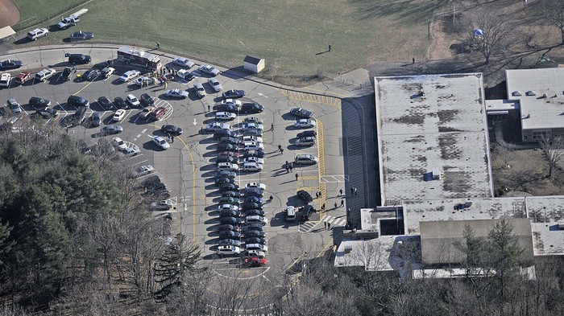
"I mean, Christ almighty, how the fuck can this happen?" sources say.
WASHINGTON—Following the fatal shooting this morning at a Connecticut elementary school that left at least 27 dead, including 20 small children, sources across the nation shook their heads, stifled a sob in their voices, and reported fuck everything. Just fuck it all to hell.
All of it, sources added.
“I’m sorry, but fuck it, I can’t handle this—I just can’t handle it anymore,” said Deborah McEllis, who added that “no, no, no, no, no, this isn’t happening, this can’t be real.” “Seriously, what the hell is this? What’s even going on anymore? Why do things like this keep happening?”
Continued McEllis, before covering her face with her hands, “Why?”
Despairing sources confirmed that the gunman, armed with a semiautomatic assault rifle—a fucking combat rifle, Jesus—walked into a classroom full of goddamned children where his mother was a teacher and, good God, if this is what the world is becoming, then how about we just pack it in and fucking give up, because this is no way to live.
I mean, honestly, all 315 million Americans confirmed.
“Well, I suppose we have to try to pick up the pieces and make some sort of sense of this tragedy and—you know what? Fuck it, I can’t do this,” said Connecticut resident Michael Zaleski, his remarks understandable given the circumstances, because, holy shit, what else can one say? “I’m sorry, but I can’t fucking do this. Can you? Can anyone?”
Witnesses said the gunman fired at least 100 rounds during his deadly rampage, which, according to children in the school—goddamnit, how? How? Twenty children. Dead. In a fucking school.
No. No, no, no.
“I just feel so [why does it even matter what this person said when no words can bring 20 dead kids back to life?]” said some person who, just like everyone else, is completely unable to process or handle any of this. “It’s awful. Just too awful to bear.”
Americans reported feelings of overwhelming disgust with whatever abhorrent bastard did this and with the world at large for ever allowing it to happen, as well as with politicians, with the NRA, and above all with their own pathetic goddamn selves, sitting in front of a fucking computer instead of doing fucking anything to help anyone—Christ, as if that were even fucking possible, as if anyone could change what happened, as if the same fucking bullshit isn’t going to keep happening again and again and fucking again before people finally decide it’s time to change the way we live, so what’s the point? What the hell is the goddamned point?
“I…” said Tom Miller, 27, after reading an article about the tragedy online. “I just…”
“…” he added.
At press time…screw it, there’s nothing else to say.

American Life Turns Into Bad Jerry Bruckheimer Movie Sep 26, 2001
NEW YORK—In the two weeks since terrorists crashed hijacked planes into the World Trade Center and Pentagon, American life has come to resemble a bad Jerry Bruckheimer-produced action/disaster movie, shellshocked citizens reported Tuesday.
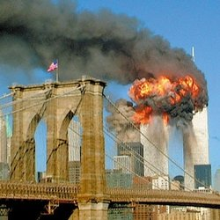An actual scene from real life.
"Terrorist hijackings, buildings blowing up, thousands of people dying—these are all things I'm accustomed to seeing," said Dan Monahan, 32, who witnessed the fiery destruction of the Twin Towers firsthand from the window of his second-story apartment in Park Slope, Brooklyn. "I've seen them all before—we all have—on TV and in movies. In movies like Armageddon, it seemed silly and escapist. But this, this doesn't have any scenes where Bruce Willis saves the planet and quips a one-liner as he blows the bad guy up."
"Did you hear that the plane that hit the Pentagon was supposed to crash into the White House?" Monahan continued. "It would have looked just like that scene in Independence Day. Only real."
Fellow New Yorker Bradley Martin, 25, was similarly shaken.
"This isn't supposed to happen in real life," Martin said. "This is supposed to be something that happens in the heads of guys in L.A. sitting around a table, trying to figure out where to add a love interest."

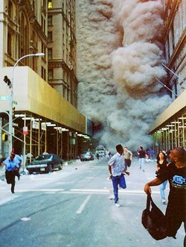
"I always thought terrorists blowing shit up would be cool," Martin continued. "Like, if the Pentagon was bombed, I figured they'd mobilize a special elite squadron of secret-agent ninjas, and half of them would be hot babes. How could I ever think that? This is actually happening, and it's just not cool at all."
For nearly two full weeks, Americans sat transfixed in front of their televisions, listening to shocked newscasters struggle to maintain their composure while describing events that would have been rejected by Hollywood producers as not believable enough for a Sylvester Stallone vehicle. All the familiar action-movie elements were there: terrorists taking over a plane, panicked crowds, huge fireball explosions, Secret Service agents ushering the president to a secret underground military base in Nebraska to plan the next move. A news report revealed that the terrorists had planned to strike Air Force One. At any moment, it seemed a squadron of alien warships would materialize and begin to menace Jeff Goldblum.
"I read that the plane that crashed near Pittsburgh didn't hit its target because the passengers fought back," said Modesto, CA, dental receptionist Sandra Barkum through tears. "I just kept thinking, that's what Wesley Snipes did in Passenger 57. Except, in the end, Wesley Snipes lived."
Another scene not from a movie.
When the president finally appeared on TV, it was George W. Bush addressing the nation, not Bill Pullman or Harrison Ford. At the conclusion of his address, Bush did not grab a leggy blonde reporter out of the crowd and kiss her. When Americans finally staggered into the streets, desperate to talk to anyone to try to make sense of what they had just seen, there were no Attack On America collector cups waiting for them at Taco Bell. The dead and injured did not, like Jon Voight, stand up in their wheelchairs as the music swelled. And Ben Affleck was nowhere to be seen.
"There are Air Force jets flying over Manhattan and warships in New York harbor, but none of it is exciting or entertaining at all," said Wall Street broker Irwin Trotter, 47, among the lucky ones who walked away from the destruction. "If the world were going to suddenly turn into a movie without warning, I wish it would have been one of those boring, talky Merchant-Ivory ones instead. I hate those movies, but I sure wish we were living in one right now."
Despite a widespread call for military retaliation among the populace, the prospect of prolonged conflict offers little comfort.
"In the movies, when the president says, 'It's war,' that usually means the good part is just about to begin," said hardware-store owner Thom Garner of Cedar Rapids, IA. "Why doesn't it feel that way now? It doesn't feel like the good part is about to begin at all. It feels there's never going to be another good part again."
The collective sense of outrage, helplessness, and desperation felt by Americans is beyond comprehension. And it will be years before the full ramifications of the events of Sept. 11 become clear. But one thing is clear: No Austrian bodybuilder, gripping Uzis and striding shirtless through the debris, will save us and make it all better. Shocked and speechless, we are all still waiting for the end credits to roll. They aren't going to.

