Name:
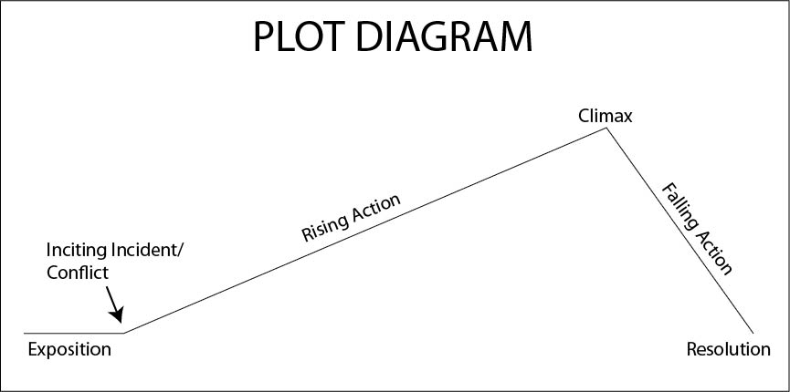
O’Brien “The Lives of the Dead” Plot Diagram

