The Invisible War Viewing Guide
Kori Cioca
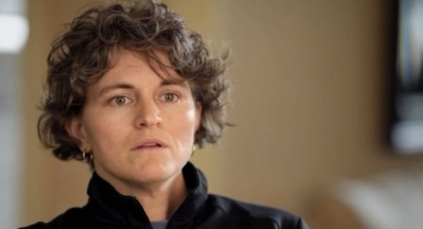 Trina McDonald
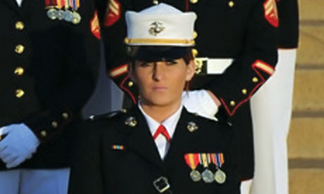Ariana Klay
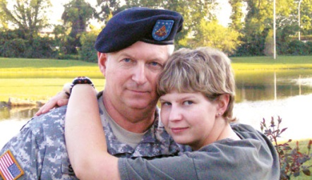 Hannah Sewell
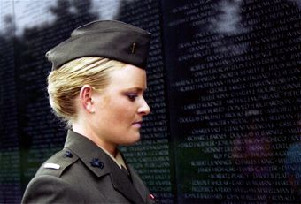 Elle Helmer
Jessica Hinves
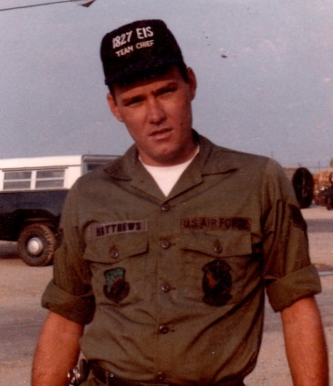 Michael Matthews
Discussion Questions
- What do you think the title of the film means?
- In the film, Family Advocacy Law Enforcement Training Division Chief Dr. Russell Strand says, “Masculinity cannot be victimized. Because if you’re a leader—a masculine person—and you’re victimized, then you’re weak.” What does this statement mean to you? What does it imply about the definition of masculinity within the armed forces? What about the definition of femininity?
- Do you think it is possible for our society to respect women who are in positions of strength and authority?
- Do you think women are sexualized in all professions? Are circumstances different for women in the military, as compared to women in other professions?
- Do you think the risks the victims took in coming forward were worthwhile? In their place, do you think you would have come forward?
- Experts in the film point out that military sex offenders who are not caught and prosecuted within the military justice system may return to civilian life and commit the same crimes against a civilian population. How does this affect your feelings about how rape should be prosecuted within the military?
- THE INVISIBLE WAR reveals that many service members who report sexual assault and harassment are treated as though their dress, behavior or alcohol consumption encouraged the attacks. Why do you think this kind of “victim blaming” occurs? Have you heard these comments before?
- In an interview on ABC’s The View, Coast Guard Seaman Kori Cioca explained that her rape was preceded by months of harassment. What do you think is the relationship between harassment and assault? Is one tolerated more than another? Do you think that changes in the way harassment is punished would affect the incidence of rape?
- Why do you think rates of military sexual assault are double what they are in civilian society? What explanations do the film’s experts provide? Do you agree with them?
- THE INVISIBLE WAR ends with a federal court’s ruling that rape is an “occupational hazard” of military service. What is your reaction to this? If you were fighting this ruling in court, what evidence would you bring to counter this interpretation?

