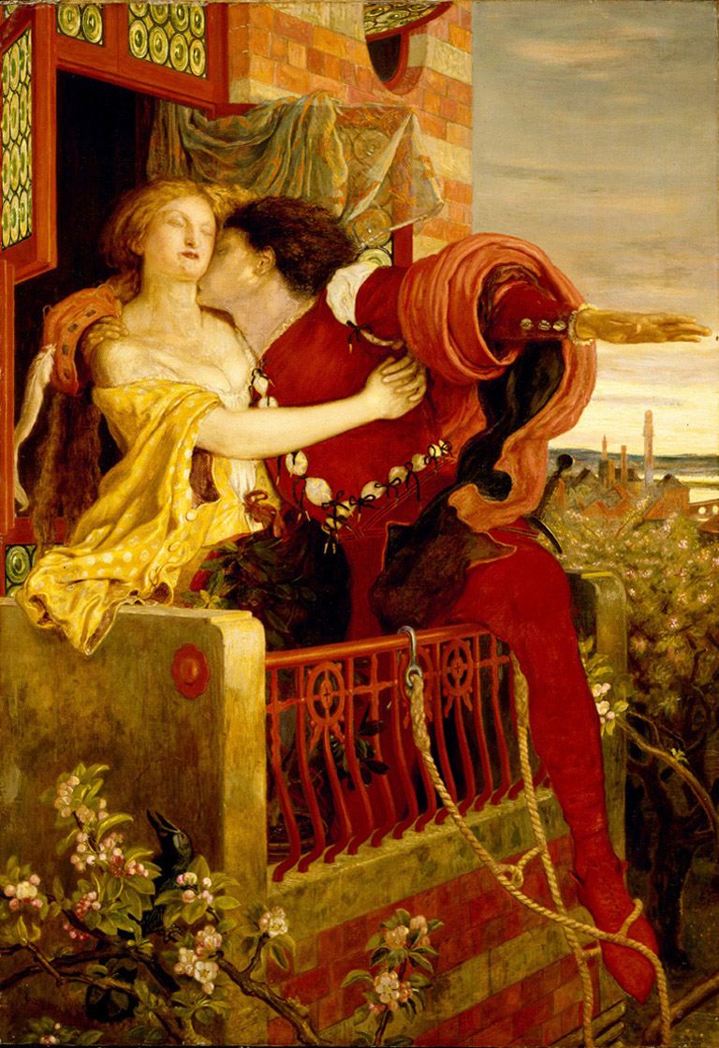
Name: _____________________
Block: _____________________
Date: ______________________

Romeo and Juliet Play Project

Now that you’ve finished reading and watching Romeo and Juliet, it’s time that we enhanced our understanding of Shakespeare’s masterpiece by acting it out. With the help of Nick Newlin’s book, The 30-Minute Shakespeare: Romeo and Juliet, we will bring four (4) key scenes from Romeo and Juliet to life.

The Scenes: Please circle the one you’ve been assigned

- Act I Scene i--the initial brawl, i.e the introduction to Shakespeare’s Verona and characters.
- Act II Scene ii- The balcony scene. One of the most famous and romantic scenes in all of literature.
- Act III Scene v--Romeo leaves, and Juliet disobeys her father and seeks out Friar Lawrence for help.
- Act V Scene iii-- The play’s conclusion.

The Requirements:

- Teamwork--all students should have an equal part in your given scene.
- Reciting lines--you are not required to have memorized your lines, but should be familiar enough with them that you aren’t stumbling over the words or merely reading them from the page
- Costumes and props--you should make effective use of visual effects for this project. Bring the play to life by looking like your characters!
- Movement--Did you move about on stage? You should act like your characters are. Dr. Newlin precedes most lines with a stage direction, i.e. “turns away”, “falls to her knees”, etc.
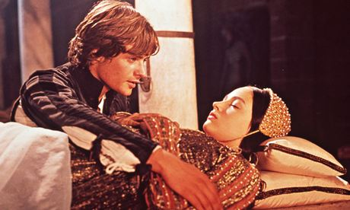
- Overall enthusiasm--Did you effectively bring the play to life as a group?

