Name:
Mr. Haflin
American Studies
Date:
Dark Romanticism Creative Essay
Background: Romanticism followed American Industrialization, when authors saw faults in the current system of life for the typical citizen. Artists turned to nature, imagination, and the individual as inspiration for personal development. Now that we’ve read short stories and poems from the Dark Romantics, we’re ready to create our own work of fiction.
Prompt: Using your knowledge of Dark Romanticism, write a short story in the style of Nathaniel Hawthorne and Edgar Allan Poe, i.e. create a piece of Dark Romantic fiction. Then, write a complete paragraph explaining the traits of Dark Romanticism in the story.
Requirements:
- Your story should have a complete story arc (Exposition, Rising Action, Climax, Falling Action, Denouement)
- Your story should incorporate at least three (3) traits of Dark Romanticism as listed on the background sheet.
- You must use strong word choice in order to effectively set the mood
- You should adequately proofread your story to correct grammar and spelling issues.
- Write a single paragraph explaining the three traits of Dark Romanticism used in the story (minimum of two sentences each).
Pre-Writing Questions (Brainstorming):
- Ask four classmates about their worst fears and list them here.

- Ask three classmates their passions and write their answers here.

- Reflect upon your own fears and passions and write them here.
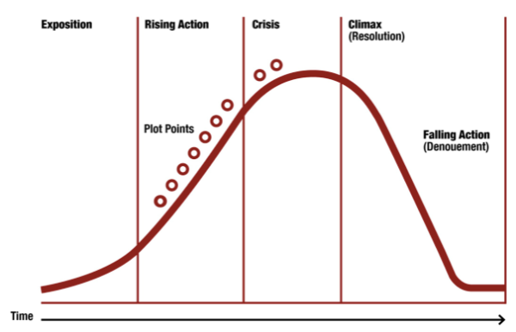
- Draft the story arc here:

Name:
Turnitin.com (leave this blank)
Category | 4 (Excellent) | 3 (Good) | 2 (Okay) | 1 (Poor
Complete Story Arc  -All 5 parts of plot present | All five elements of plot present in a creative way | All five elements of plot present | Four of five elements of plot present | Some elements of plot are skipped
Traits of Dark Romanticism  -3 Required | All three Dark Romanticism traits are present in a creative manner | All three Dark Romanticism traits are present | Only two elements of Dark Romanticism present | One or fewer elements of Dark Romanticism present
Word Choice | Creative word choice; spooky without going over the top | Creative word choice; spooky overall, but some passages should be enhanced | Word choice adequately fits the story, but is relatively lackluster | Word choice does not reflect the requirements
Spelling, Grammar  -Proofreading | Great proofreading; no issues with spelling or grammar | 1-2 Spelling or grammar issues | 3-4 Spelling or grammar issues | Far too many spelling or grammar issues
Explanation of Dark Romanticism Traits  -2 sentences per trait | Explanation includes at least two expansive sentences detailing DR trait usage | Explanation includes two sentences detailing DR trait usage | Explanation includes one sentence per trait | Explanation is inadequate with regards to detail

Please see my comments for strengths/weaknesses

