Name of Myth
Your Name

Summary

Summary summary summary summary summary. Summary summary summary summary summary. Summary summary summary summary summary. Summary summary summary summary summary. Summary summary summary summary summary. Summary summary summary summary summary. Summary summary summary summary summary.

Plot Chart

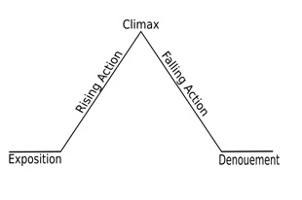
Importance and Significance of the Myth

Type here the importance and significance of the myth in complete sentences. Type here the importance and significance of the myth in complete sentences. Type here the importance and significance of the myth in complete sentences. Type here the importance and significance of the myth in complete sentences. Type here the importance and significance of the myth in complete sentences. Type here the importance and significance of the myth in complete sentences.

Draw Picture Here

