Myth Project

- You will be assigned a myth to read and for which you will answer the questions.
- Answers must be hand-written in class
- Answers must be in complete sentences
- Answers be revised and typed at home for homework
- Make a plot chart according to the following:
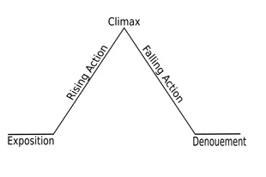
- Write a one paragraph summary of the myth.
- Five to Six Complete Sentences
- Use detail
- Describe the purpose of the myth and what it explains (example: about mankind, nature, etc.)
- One Paragraph
- Five to Six Complete Sentences
- At Least One Quote
- Draw a picture that clearly illustrates one of the most important scenes from the myth.
- Must be Neat
- Must Be Hand Drawn

Metis and Athena: Yeelin
Dione, Aphrodite, and Eros: Ryan Beers
Hera, Hephaestus, and Ares: Rachel
Leto and Apollo: Aidan
Leto and Artemis: Sean Clements and Jack
Hera, Hephaestus, and Ares: Joey Rochte
Demeter and Persephone: Drew
Nemesis: Cailey Desharnais
Prometheus: Joey Dion
Pandora: Sean Griffin and Will
Arachne: Sean Hill
Niobe: Ellie
Midas: Olivia
Icarus and Daedalus: Addison and Jared
Pygmalion: Robert
Narcissus and Echo: Henry
Orpheus and Eurydice: Andrew
Atalanta: Molly

