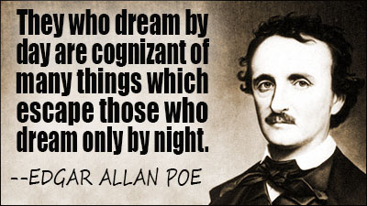
Name:
Mr. Haflin
American Studies
Date:
Edgar Allan Poe Background Notes
General Knowledge
- Edgar Allan Poe is one of the best-known American authors, but his literary legacy is complex and confusing. Poe pioneered many of the most enduring forms of American popular culture, including the _____________ story, _______________ fiction, and the ____________ tale.
- Poe maintained that authors should begin by considering their writing’s effect on _______________.
Early Life
- Poe suffered the early death of his ________________.
- His father ________________ Poe from the family fortune, even though an illegitimate child was provided for.
Personal Life
- Poe lacked apparent control over his _____________, his ________________, and his ______________.
- In 1836, at the age of 18, Poe married his 14-year-old cousin _______________.
- After six years of marriage, Virginia suffered a __________________________, and never fully recovered. She died in 1847.
- Poe himself died in _____________, at the age of 40. Like so many of his stories, the cause of death remains a ________________.
Poe’s Writing and Beliefs
- Like most Dark Romantics, Poe did not believe in the ___________________ of people.
- Poe also believed in the human capacity for ________________.
- Many of Poe’s stories involve the gothic elements of ________________, _______________, and __________________.
- Some motifs to consider while reading Poe include:
  - Death of a Beautiful Woman
  - Madness
  - Derangement
  - Violence
  - Obsession

