Born on the Fourth of July
Viewing Guide

Pre-war

During War + Rehab from injuries
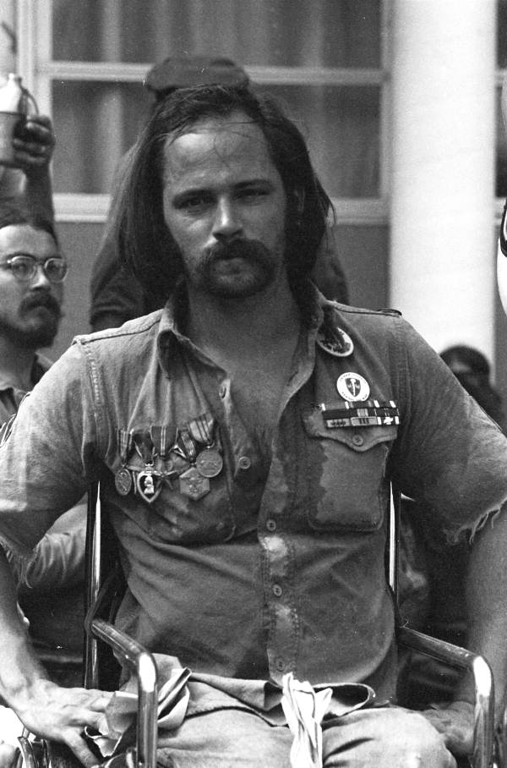

Post War and Activism

Members of the Lost Generation seemed to:

Exhibit grace under pressure
View life as transitory
Enjoy life’s pleasures (indulgence)
Are Physically/emotionally broken
Have little regard for consequence
Struggle to confront truth
Experience a loss of faith
Are emotionally detached or indifferent

Although Tim O’Brien writes about the Vietnam War, consider how these traits, which were once applied to only World War I veterans, can apply to any war veteran.

